Bills Exchange API User Documentation

Please follow the cases provided here to perform the respective actions on the BillsExchange Rest API.

Here are the operations/actions supported by the REST API:

1. GetAvailableChange
2. GetBillAmount
3. AddBill

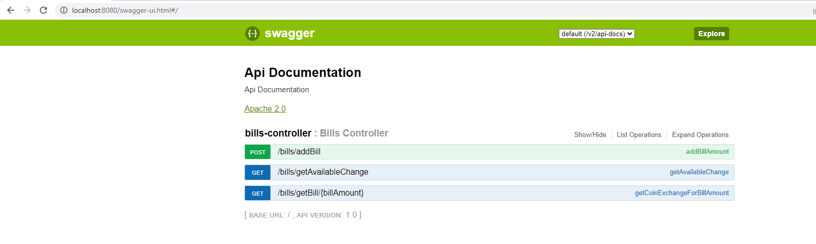

**Case-1:**

***GetAvailableChange:*** Check the availability of the change before proceeding with the bill.

As per the configuration, API contains 100 coins for each denomination. You can verify it out through this API.

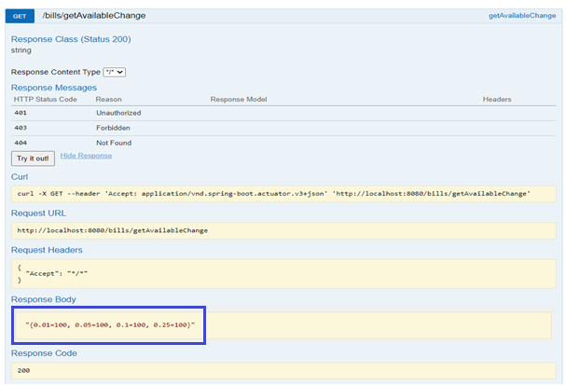

**Case-2:**

***GetBillAmount:*** Get the Change in the form of coins for the bill amount submitted.

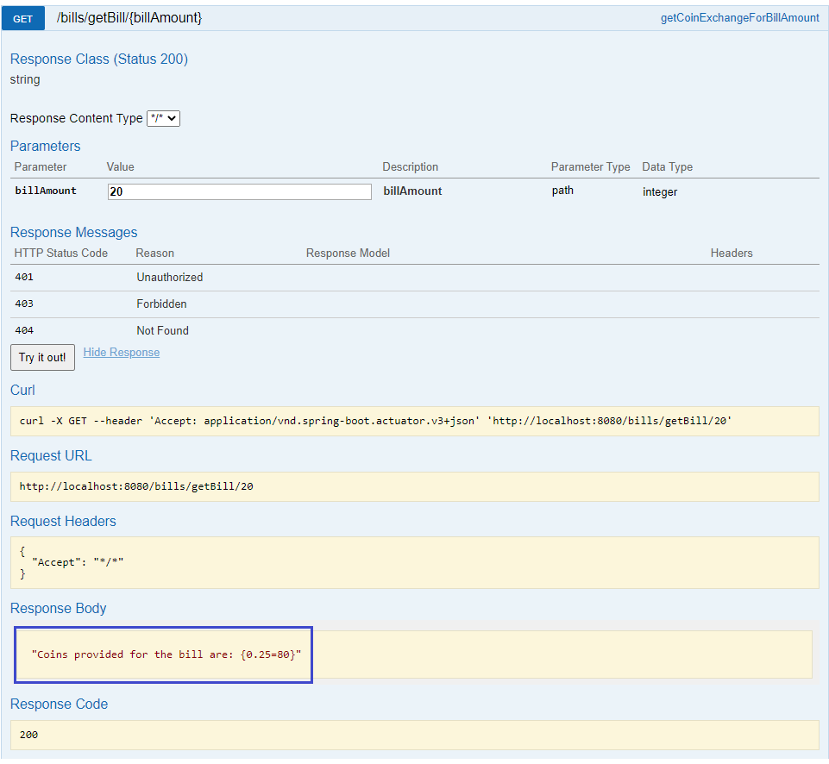

**Case-3:**

***AddBill:*** As per the norms, a bill has to be registered first before collecting the change in the form of coins. So, User has given an option to register his/her bill by providing a valid bill amount.

